**10 LINUX COMMANDS**

1. df - command

Use case: This provides information on the available hard disk space on your system.

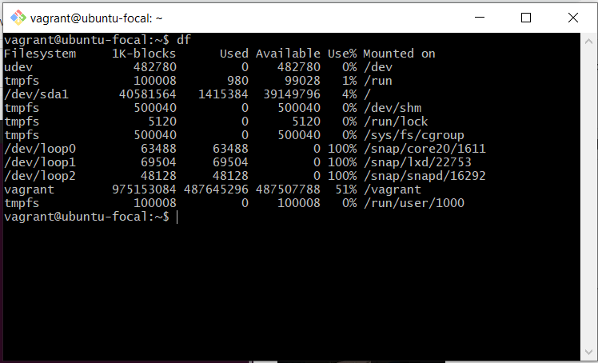

2. ls - command

Use Case: This command lists all files and directories in the present working directory.

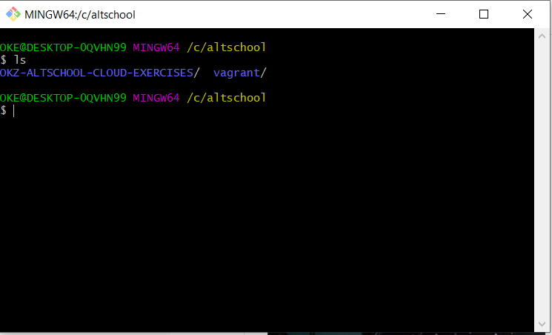

3. sudo – command

Use Case: This command allows normal or regular users to run programs on the computer with the security privileges of who we call superuser or root.

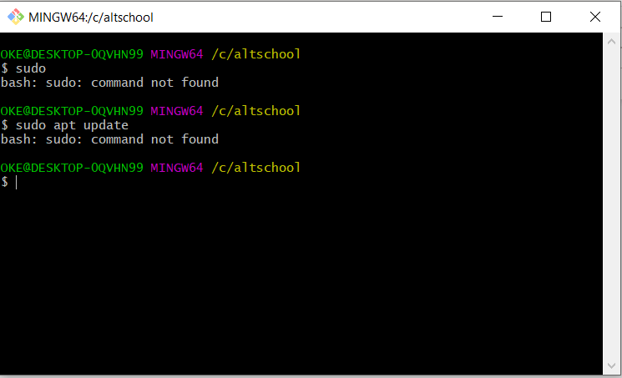

4. env – command

Use Case: This command displays all the variables in an environment.

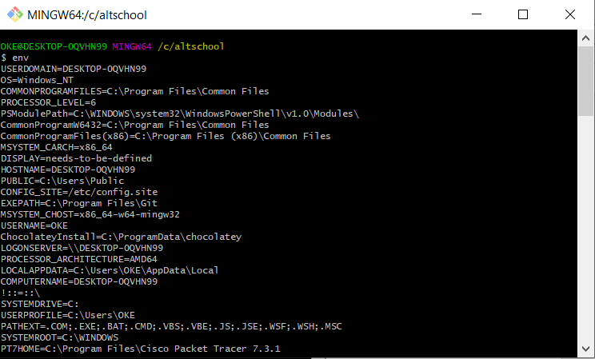

5. clear – command

Use Case: This command clears everything on the terminal.

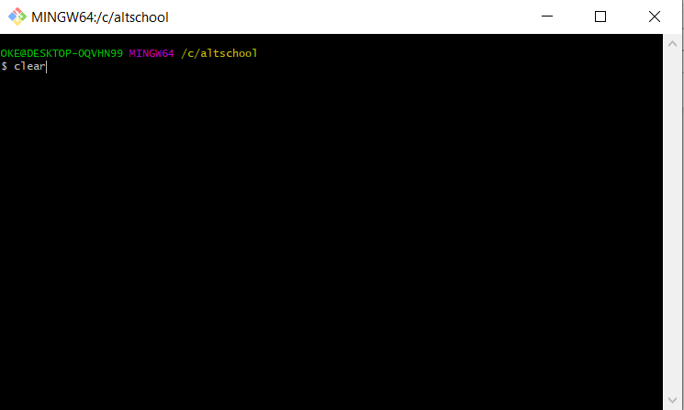

6. cat filename – command

Use case: This displays the content of a file

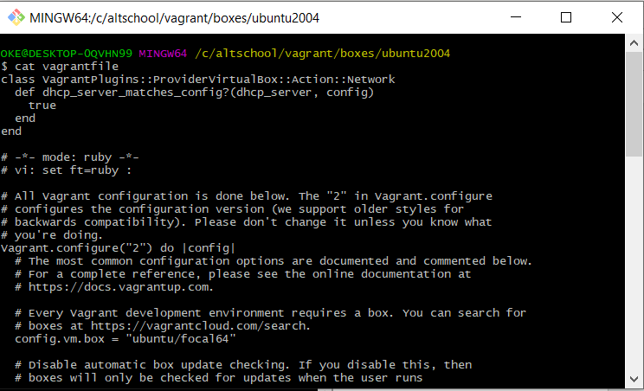

7. finger – command

Use Case: This command displays information of all users logged into the system.

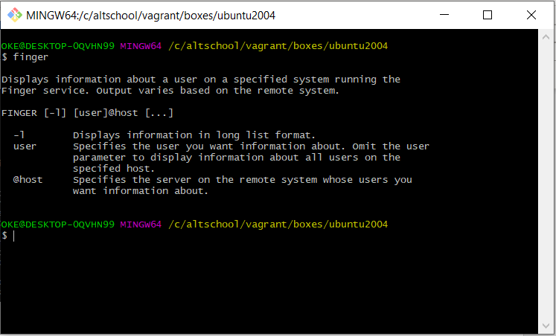

8. lsof -command

Use Case: This will list all opened files on the system.

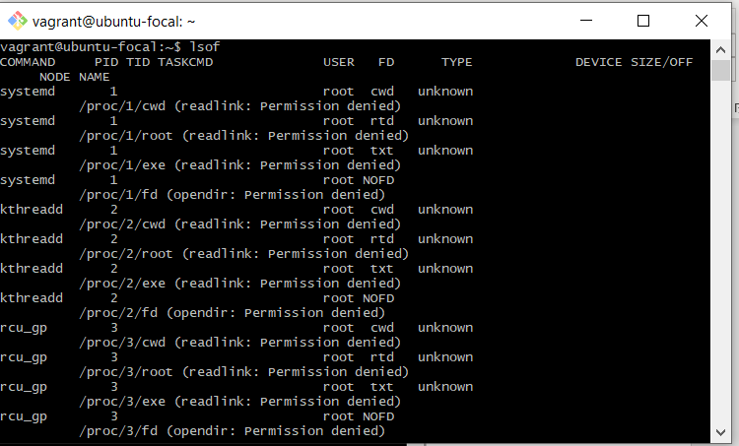

9. mkdir – command

Use case: This creates a directory in your present working directory.

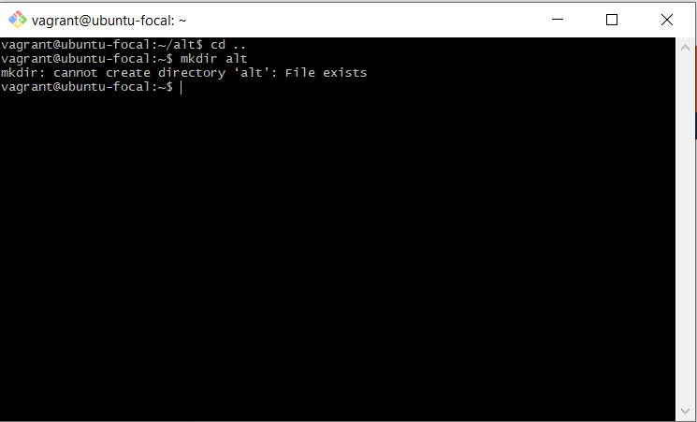

10. rm -r (directory) – command

Use Case: This removes or delete the directory from the system

